Methods

*Study system*

We used a dataset of opportunistic butterfly observations made by citizen scientists in North Carolina. These data are hosted and maintained by the North Carolina Biodiversity Project and North Carolina State Parks (LeGrand and Howard 2021). The database was launched in 1993 and covers North Carolina’s 177 known butterfly species. It is updated yearly and includes at least 232,779 records from 1899 to 2020. Each entry lists the common name, date, observer name, number of individual butterflies observed, and county. Many entries include additional description of the location.

We selected observations from the North Carolina Triangle region (Durham, Orange, and Wake Counties) since these counties had the highest consistent sampling effort (Fig. S1). In addition, Durham, Orange, and Wake Counties are all within the Piedmont ecoregion and have similar climatic conditions. We selected records collected between 1993 and 2020 because there are few records prior to this interval. Out of these years, we selected species that had least 10 years with at least 10 unique observer dates per year, and excluded species that are migratory in the Piedmont ecoregion. For a given species, we also omitted years with less than 10 unique observer dates from analyses. We treated *Erynnis horatius* and *E. juvenalis* as a single taxon, *Erynnis* spp., since observers frequently consider time of year to distinguish these very similar species, rendering it impractical to meaningfully interpret any differences in phenology. For the same reason, we also treated *Celastrina ladon* and *Celastrina neglecta* as a single taxon, *Celastrina* spp. We included a total of 38 species or taxa (hereafter referred to as species) in our analysis. (Table S1). We used R (version 4.1.1) for all analyses.

*Spring appearance date*

Since first record of appearance is heavily subject to outliers (van Strien et al. 2008), we defined spring appearance date as the date on which 10% of records had been collected for each unique species-year. For example, if a butterfly species has 26 records in a given year, then the spring appearance date would be the date on which the next whole number above 2.6 records occurred (illustrated in Fig. S2).

To limit the outsize influence of mass survey efforts such as BioBlitzes and North American Butterfly Association butterfly counts (https://www.naba.org) we defined a single record to be each unique combination of observer, date, county, and species. Number of individuals observed per record was not considered in our analyses.

*Spring temperature*

Mean monthly temperature data was obtained from the PRISM Climate Group (Oregon State University). We used the packages ‘raster’ (Hijmans 2022) and ‘rgdal’ (Bivand 2022) to subset spatial temperature data from Durham, Orange, and Wake Counties. For a given year, we defined the spring temperature as the mean monthly temperature for each county averaged over a static 4-month window (March to June) and then averaged across the three counties. We selected this window because spring temperatures strongly dictate the variation in the timing of insect emergence (Forister and Shapiro 2003, Dell et al. 2005).

*Phenological response*

For each species, we fit a linear regression model in which spring appearance date was the response variable and either spring temperature or year were the explanatory variables. We omitted highly influential data points from our linear regression models by excluding points where Cook’s distance was greater than four divided by the total number data points for each species. For each species and each model (spring appearance date vs. spring temperature or year), we generated a dataframe which included the slope, mean spring appearance date, and the standard deviation of the spring appearance date. We use slope as an estimate for a given species’ phenological sensitivity to changes in spring temperature and year.

*Species traits*

To examine whether species traits play a role in phenological sensitivity, we considered the mean spring appearance date, overwintering stage, and voltinism of each species as factors in our models. Mean spring appearance date was included as a continuous estimate of whether each species appears earlier or later in the year (Table 1). We treated overwintering stage as a factor (larvae, pupae, or adults) and favored the overwintering stage specific to the southeast US, especially the Piedmont region of NC. We treated voltinism as a continuous factor and again favored values that were specific to the Piedmont region of NC. In cases where a species had variable voltinism, we selected the average value. For example, if a species has 3-4 generations per year, we assigned a value of 3.5. Voltinism and overwintering stage were referenced chiefly from LeGrand and Howard 2022, but other sources include Butterflies and Moths of North America (https://www.butterfliesandmoths.org) and University of Florida Department of Entomology and Nemotology (https://www.entnemdept.ufl.edu/) (see Table S1).

We fit a series of linear mixed effects models wherein mean spring appearance date, voltinism, and their interactions were the fixed effects and slope was the response variable. We ran separate models for both spring temperature and year. In all models, we inversely weighted the values by the standard deviation of the spring appearance date (Table 1) to limit the influence of species with extremely variable spring appearance dates, since these are likely to be less biologically relevant. If the model was significant, we compared the base model with a separate model that included overwintering stage as a factor. Linear mixed effects models were run using the package ‘lme4’ (v.1.1.27.1, Bates et al. 2017) and summarized using the ‘Anova’ function within the package ‘car’ (v.3.0.11, Fox and Weisberg 2011). We then compared simple (without overwintering stage) and complex models (with overwintering stage) using an ANOVA.

**Results**

*Phenological response*

Between 1993 and 2020, *Thorybes bathyllus* and *Polites origenes* experienced a significant correlation between spring appearance date and year. Both of these relationships were somewhat positive, such that spring appearance dates increased slightly with year (Table 1). Overall, there were 16 negative and 22 positive slopes, demonstrating a roughly even spread of slope values around zero (Fig. 1a).

Using temperature as the predictor variable, 12 species experienced a significant correlation between spring appearance date and temperature, all of which demonstrated a negative relationship. These species appeared between 3.4 - 27.3 days earlier for every 1℃ increase in average spring temperature (Table 1). Out of the 38 species, there were 35 negative slopes and 3 positive slopes (Fig 1a), indicating a trend of advancing spring appearance date with increasing temperature for nearly all species.

*Species traits*

In a linear regression model examining the effect of species traits on the slope of spring appearance date vs. year, slope did not vary significantly with mean spring appearance date (F1,34 = 0.12, p = 0.73, Fig. ), voltinism (F1,34 = 0.0015, p = 0.97), or their interaction (F1,34 = 0.65, p=0.43).

In a separate linear regression model examining the effect of species traits on the slope of spring appearance date vs. spring temperature, slope varied significantly with mean spring appearance date (F1,34 = 6.28, p = 0.02), such that species that appear later in the year tended to have more negative slopes compared to species that appear earlier in the year. Slope also varied significantly with the interaction between voltinism and mean spring appearance date (F1,34 = 5.84, p = 0.02), with late, higher voltinism species generally being more sensitive to changes in temperature (Fig 2). We did not observe a significant effect of voltinism alone on slope (F1,34 = 0.63, p = 0.43). Adding overwintering stage to the model did not significantly improve the model fit (ANOVA, F2,32 = 0.10, p = 0.91).

**Table 1.** Summary of slopes, r-squared values, and p-values from linear regression models of spring appearance date vs. year and spring temperature in NC Triangle butterfly species, in addition to the mean and standard deviation (SD) of spring appearance date for each species. Mean and SD spring appearance date may differ between year and spring temperature models due to differences in values omitted due to high Cook’s Distance value.

|  |  |  |  |  |  |  |  |  |  |  |
| --- | --- | --- | --- | --- | --- | --- | --- | --- | --- | --- |
|  | **Spring appearance date vs. year** | | | | | **Spring appearance date vs. spring temperature** | | | | |
| **species** | **slope** | **r-squared** | **p-value** | **mean spring appearance date** | **SD spring appearance date** | **slope** | **r-squared** | **p-value** | **mean spring appearance date** | **SD spring appearance date** |
| *Abaeis nicippe* | 1.381 | 0.075 | 0.176 | 106.962 | 39.837 | 4.095 | 0.007 | 0.681 | 102.240 | 32.289 |
| *Ancyloxypha numitor* | 0.241 | 0.024 | 0.550 | 140.588 | 9.481 | -8.473 | 0.090 | 0.198 | 148.400 | 20.990 |
| *Anthocharis midea* | -0.002 | 0.000 | 0.992 | 72.542 | 5.556 | -6.432 | 0.627 | 0.000 | 72.409 | 5.492 |
| *Asterocampa celtis* | -0.207 | 0.027 | 0.481 | 140.571 | 9.610 | -8.058 | 0.372 | 0.003 | 140.571 | 9.610 |
| *Atalopedes campestris* | -0.789 | 0.048 | 0.271 | 165.593 | 28.503 | -25.277 | 0.378 | 0.001 | 168.370 | 29.155 |
| *Battus philenor* | 0.513 | 0.079 | 0.243 | 108.632 | 12.424 | 0.815 | 0.002 | 0.870 | 106.368 | 12.615 |
| *Calycopis cecrops* | 0.046 | 0.000 | 0.969 | 126.682 | 36.787 | -2.057 | 0.002 | 0.854 | 129.304 | 38.078 |
| *Celastrina spp* | 0.143 | 0.016 | 0.530 | 81.778 | 9.382 | -1.947 | 0.020 | 0.494 | 82.346 | 9.082 |
| *Colias eurytheme* | 0.016 | 0.000 | 0.974 | 95.760 | 16.996 | -4.547 | 0.027 | 0.414 | 98.926 | 19.977 |
| *Cupido comyntas* | -0.067 | 0.003 | 0.784 | 105.846 | 9.456 | -4.910 | 0.118 | 0.086 | 108.615 | 9.761 |
| *Cyllopsis gemma* | -0.085 | 0.006 | 0.772 | 97.765 | 7.726 | -4.765 | 0.086 | 0.222 | 99.263 | 9.955 |
| *Epargyreus clarus* | 0.223 | 0.016 | 0.529 | 124.926 | 14.293 | -0.896 | 0.002 | 0.829 | 124.077 | 13.380 |
| *Erynnis spp* | 0.080 | 0.011 | 0.623 | 87.840 | 6.176 | -4.697 | 0.183 | 0.033 | 86.800 | 7.200 |
| *Euphyes vestris* | 0.067 | 0.001 | 0.888 | 152.143 | 16.536 | -7.891 | 0.184 | 0.059 | 149.950 | 13.473 |
| *Eurytides marcellus* | -0.672 | 0.208 | 0.066 | 91.059 | 10.317 | 0.949 | 0.007 | 0.742 | 92.118 | 8.313 |
| *Hermeuptychia sosybius* | -0.135 | 0.011 | 0.588 | 115.179 | 10.378 | -6.020 | 0.152 | 0.045 | 114.963 | 10.512 |
| *Lerema accius* | 0.194 | 0.003 | 0.791 | 194.760 | 26.911 | -5.993 | 0.025 | 0.450 | 199.480 | 24.575 |
| *Lethe anthedon* | 1.045 | 0.201 | 0.125 | 148.615 | 13.586 | -11.086 | 0.387 | 0.023 | 148.615 | 13.586 |
| *Lethe appalachia* | -1.117 | 0.120 | 0.360 | 139.778 | 8.814 | -4.065 | 0.046 | 0.505 | 141.750 | 14.710 |
| *Libytheana carinenta* | 0.513 | 0.020 | 0.545 | 78.619 | 28.092 | -0.454 | 0.000 | 0.965 | 88.364 | 32.669 |
| *Limenitis archippus* | 0.687 | 0.134 | 0.103 | 139.000 | 16.559 | -3.054 | 0.012 | 0.624 | 141.500 | 19.966 |
| *Limenitis arthemis astyanax* | 0.349 | 0.057 | 0.232 | 130.111 | 11.643 | -2.749 | 0.040 | 0.326 | 131.346 | 9.907 |
| *Megisto cymela* | 0.064 | 0.029 | 0.577 | 136.385 | 2.434 | -3.386 | 0.311 | 0.025 | 137.063 | 4.106 |
| *Papilio glaucus* | 0.080 | 0.005 | 0.738 | 90.440 | 8.832 | -2.871 | 0.040 | 0.309 | 90.857 | 10.334 |
| *Papilio polyxenes* | -0.345 | 0.055 | 0.269 | 101.292 | 11.265 | -3.134 | 0.042 | 0.348 | 100.304 | 10.403 |
| *Papilio troilus* | -0.150 | 0.008 | 0.668 | 109.885 | 13.207 | -2.148 | 0.010 | 0.630 | 110.192 | 13.908 |
| *Phyciodes tharos* | -0.142 | 0.010 | 0.626 | 115.885 | 11.097 | -7.315 | 0.189 | 0.030 | 115.760 | 11.084 |
| *Pieris rapae* | -0.176 | 0.005 | 0.752 | 91.958 | 18.443 | -10.055 | 0.097 | 0.122 | 98.385 | 22.716 |
| *Polites origenes* | 0.484 | 0.243 | 0.038 | 145.000 | 6.869 | -0.937 | 0.003 | 0.818 | 146.895 | 10.619 |
| *Polygonia comma* | 0.751 | 0.104 | 0.134 | 75.739 | 18.094 | -2.296 | 0.011 | 0.650 | 72.429 | 14.379 |
| *Polygonia interrogationis* | -0.144 | 0.007 | 0.684 | 76.880 | 13.424 | -5.632 | 0.064 | 0.211 | 75.346 | 15.302 |
| *Pompeius verna* | -0.147 | 0.019 | 0.553 | 143.952 | 8.182 | -5.485 | 0.263 | 0.017 | 143.952 | 8.182 |
| *Pyrgus communis* | 0.961 | 0.024 | 0.461 | 141.160 | 45.752 | -27.286 | 0.197 | 0.030 | 138.292 | 44.396 |
| *Speyeria cybele* | -0.138 | 0.009 | 0.768 | 145.750 | 8.148 | -8.521 | 0.326 | 0.033 | 145.571 | 9.419 |
| *Strymon melinus* | 1.162 | 0.084 | 0.134 | 145.107 | 32.962 | -16.468 | 0.123 | 0.085 | 146.880 | 29.789 |
| *Thorybes bathyllus* | 0.917 | 0.369 | 0.036 | 132.500 | 9.672 | -2.935 | 0.048 | 0.473 | 132.692 | 9.286 |
| *Vanessa virginiensis* | 0.330 | 0.027 | 0.417 | 112.074 | 16.703 | -5.346 | 0.055 | 0.258 | 114.200 | 15.335 |
| *Wallengrenia otho* | -0.185 | 0.018 | 0.620 | 151.125 | 8.709 | -7.943 | 0.533 | 0.001 | 151.125 | 8.709 |

**Figure 1.** Violin plots illustrating the distribution of slope values by species traits. Red dots indicate the mean, and error bars indicate the standard deviation. A) Distribution of earlydate versus temperature slopes and year slopes. B) Distribution of earlydate versus temperature slopes and year slopes by voltinism. The slopes for species with 3.5 and 5 voltinism are not displayed because there is a single value for each. C) Distribution of earlydate versus temperature and year by overwintering stage.

**Figure 2.** Spring appearance date vs. temperature slope plotted against mean spring appearance date. Regression lines correspond to each voltinism value, which is treated as a factor for clarity in this figure. Circles, triangles, and squares indicate species that overwinter as adults, larvae, and pupae, respectively. Grey shaded areas indicate the confidence interval of the regression model.

**Supplemental Table 1.** Summary of species and species traits included in analysis.

|  |  |  |  |  |
| --- | --- | --- | --- | --- |
| **Species** | **Family** | **Voltinism** | **Overwintering stage** | **Reference** |
| *Abaeis nicippe* | Pieridae | 3 | adults | LeGrand and Howard 2022, Florida Museum 2021 |
| *Ancyloxypha numitor* | Hesperiidae | 3 | larvae | LeGrand and Howard 2022 |
| *Anthocharis midea* | Pieridae | 1 | pupae | LeGrand and Howard 2022, BAMONA 2022 |
| *Asterocampa celtis* | Nymphalidae | 2 | larvae | LeGrand and Howard 2022, Hall and Butler 2021 |
| *Atalopedes campestris* | Hesperiidae | 3 | larvae | LeGrand and Howard 2022, NABA North Jersey Chapter 2017 |
| *Battus philenor* | Papilionidae | 3 | pupae | LeGrand and Howard 2022, Illinois Department of Natural Resources 2017 |
| *Calycopis cecrops* | Lycaenidae | 2 | larvae | LeGrand and Howard 2022, Hall and Butler 2019 |
| *Celastrina* spp. | Lycaenidae | 3 | pupae | LeGrand and Howard 2022, BAMONA 2022, Alabama Butterfly Atlas 2022 |
| *Colias eurytheme* | Pieridae | 4.5 | pupae | LeGrand and Howard 2022, BAMONA 2022 |
| *Cupido comyntas* | Lycaenidae | 4.5 | larvae | LeGrand and Howard 2022, BAMONA 2022 |
| *Cyllopsis gemma* | Nymphalidae | 3 | larvae | LeGrand and Howard 2022, BAMONA 2022 |
| *Epargyreus clarus* | Hesperiidae | 2 | pupae | LeGrand and Howard 2022, Hall 2008 |
| *Erynnis* spp. | Hesperiidae | 3 | larvae | LeGrand and Howard 2022, BAMONA 2022 |
| *Euphyes vestris* | Hesperiidae | 2 | larvae | LeGrand and Howard 2022, BAMONA 2022 |
| *Eurytides marcellus* | Papilionidae | 3 | pupae | LeGrand and Howard 2022, Hall and Butler 2020 |
| *Hermeuptychia sosybius* | Nymphalidae | 3 | larvae | LeGrand and Howard 2022, Tan and Lucky 2016 |
| *Lerema accius* | Hesperiidae | 1 | pupae | LeGrand and Howard 2022, Burgess 2018 |
| *Lethe anthedon* | Nymphalidae | 2 | larvae | LeGrand and Howard 2022, Alabama Butterfly Atlas 2022 |
| *Lethe appalachia* | Nymphalidae | 2 | larvae | LeGrand and Howard 2022, Alabama Butterfly Atlas 2022 |
| *Libytheana carinenta* | Nymphalidae | 2 | adults | LeGrand and Howard 2022, Hall and Butler 2021 |
| *Limenitis archippus* | Nymphalidae | 3 | larvae | LeGrand and Howard 2022, Wisconsin Pollinators |
| *Limenitis arthemis astyanax* | Nymphalidae | 3 | larvae | LeGrand and Howard 2022, Hall and Butler 2019 |
| *Megisto cymela* | Nymphalidae | 1 | larvae | LeGrand and Howard 2022, BAMONA 2022 |
| *Papilio glaucus* | Papilionidae | 2 | pupae | LeGrand and Howard 2022, BAMONA 2022. Note name change |
| *Papilio polyxenes* | Papilionidae | 3 | pupae | LeGrand and Howard 2022, BAMONA 2022 |
| *Papilio troilus* | Papilionidae | 2 | pupae | LeGrand and Howard 2022, BAMONA 2022 |
| *Phyciodes tharos* | Nymphalidae | 4.5 | larvae | LeGrand and Howard 2022, Alabama Butterfly Atlas 2022 |
| *Pieris rapae* | Pieridae | 5 | pupae | LeGrand and Howard 2022, BAMONA 2022 |
| *Polites origenes* | Hesperiidae | 2 | larvae | LeGrand and Howard 2022, BAMONA 2022 |
| *Polygonia comma* | Nymphalidae | 2 | adults | LeGrand and Howard 2022 |
| *Polygonia interrogationis* | Nymphalidae | 2 | adults | LeGrand and Howard 2022 |
| *Pompeius verna* | Hesperiidae | 2 | larvae | LeGrand and Howard 2022, Alabama Butterfly Atlas 2022. |
| *Pyrgus communis* | Hesperiidae | 3 | larvae | LeGrand and Howard 2022, BAMONA 2022. Note possible name change |
| *Speyeria cybele* | Nymphalidae | 1 | larvae | LeGrand and Howard 2022, Alabama Butterfly Atlas 2022. Note possible name change |
| *Strymon melinus* | Lycaenidae | 3 | pupae | LeGrand and Howard 2022, BAMONA 2022 |
| *Thorybes bathyllus* | Hesperiidae | 2 | larvae | LeGrand and Howard 2022, BAMONA 2022. Note possible name change |
| *Vanessa virginiensis* | Nymphalidae | 3.5 | adults | LeGrand and Howard 2022, Hall 2021 |
| *Wallengrenia otho* | Hesperiidae | 2 | larvae | LeGrand and Howard 2022, Burgess 2018. Note name change |

**Supplemental Figure 1.** A) A map of North Carolina counties, with NC Counties indicated in light green and Triangle counties (Durham, Orange, Wake) indicated in purple. B) Non-cumulative number of Triangle butterfly observations records per year and yearly fluctuations in mean temperature from March to June between 1993 and 2020. Map compiled using ArcGIS Version 10.6.1. County shapefile obtained from the US Census Bureau. Temperature data obtained from PRISM Climate Group (Oregon State University 2022).

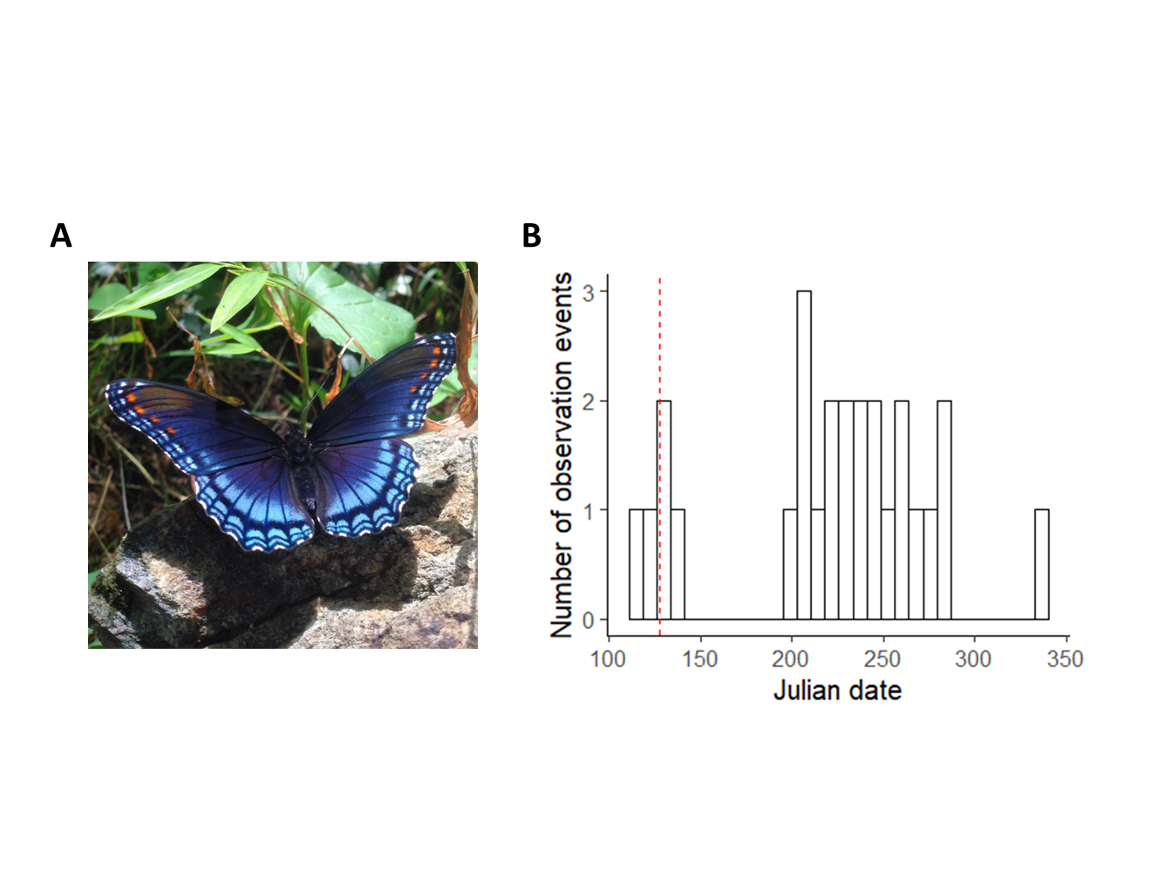

**Supplemental Figure 2.** A) Red-spotted purple (*Limenitis arthemis astyanax*), a focal species included in analyses. B) Histogram of records by julian date collected for *L. arthemis astyanax* in 2016. There were a total of 26 records for this species in 2016. The date by which the first 10% of records for that year (3 records) had been collected was on 7 May (julian date = 128), which is indicated by a vertical, dotted red line.